**M&A Status Forecast Using Decision Tree**

**Project Proposal for APMAE4990**

**By Vera Feng**

**Motivation**

70%~90% of mergers and acquisitions fail. Despite the surging business activity, business executives often find their plans fall short. The frustration coming from lengthy, unfruitful negotiations and disruption in long term strategic plans make any M&A failure a significant setback companies want to avoid. Apart from industry experience, business executives need an objective, systematic way to forecast their intended M&A deal.

**Project Description**

**Overview**

An interactive decision tool for business executives to predict a M&A deal status. As a pilot trial, this project will target M&A deals bidded by US companies, both domestically and internationally.

**Methodology**

Making predictions based on historical cases. Using a decision tree.

Step 1: Extract a subset of relevant data based on user input.

Step 2: Quietly compute and store the sample statistics.

Step 3: Output the predicted possibility of deal being completed

**Data Used**

Data employed in this project comes from Zephyr, an online reserve containing M&A deals in various countries with links to detailed financial company information. For this project, M&A deal information bidded by US companies in 2010-2016 will be used. The target companies could be US or international companies.

**User Interface Design**

The user will be asked a few questions and given a prediction of the probability of their deal being completed in each step. Their inputs are the partition parameters, based on which the system will search and extract a subset of deals of same values for all parameters. Later the percentage of completed deals in that group of deals will the calculated. This calculation repeats in each step. In the end, the user will be told an ultimate possibility of their deal being completed.

Partition parameters:

Industry → type of target company → deal type → stake → bid price ⇒ predicted deal status

Industry: pharmaceutical, telecom, automotive, etc

Target company: Domestic or International

Deal type: Institutional buy-out, Capital increase, Joint-venture, MBI / MBO, Management buy-in, Management buy-out, Merger, Demerger, Minority stake, or Share buy back

Stake: <50% or >50%

Bid Price: in several ranges

Predicted deal status: Completed, or Not Completed.

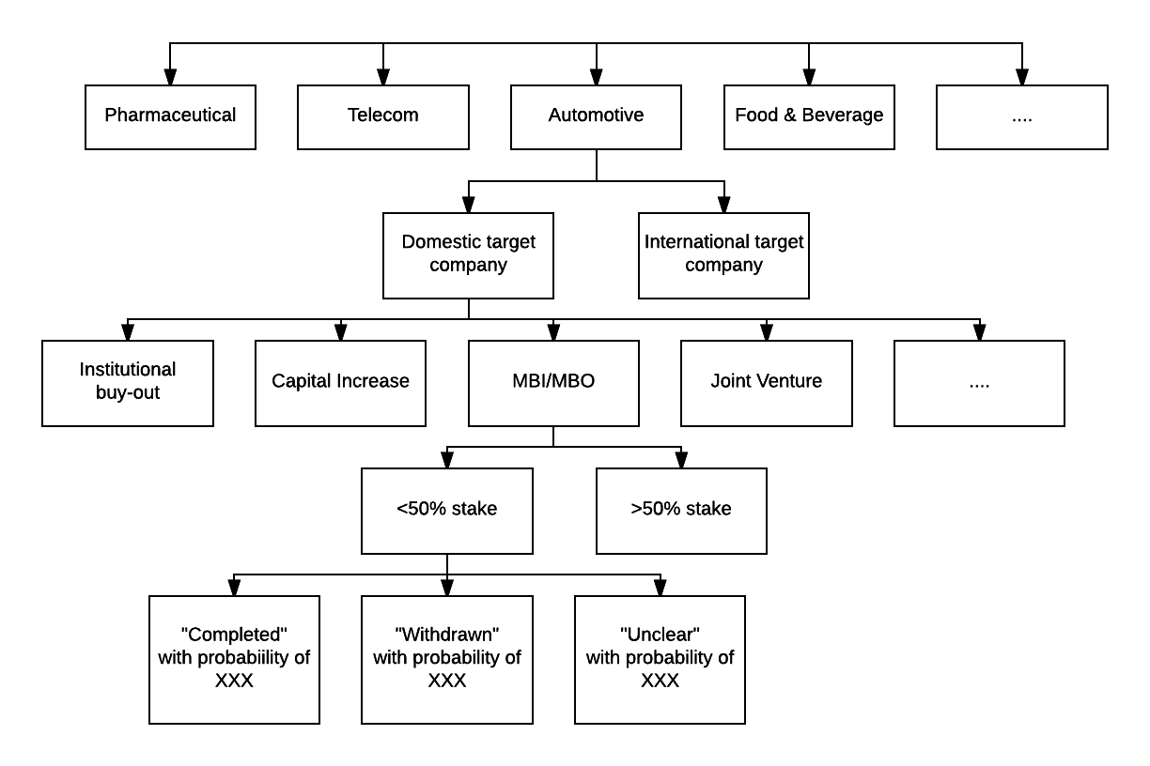

NB: Each branch of trees have the same structure.

**Actionable Timeline**

By April 6 - Data Cleaning and Management

By April 13 - Hash out Decision Tree Structure

By April 20 - Building basic codes

By April 27 - User Interface Design

By May 1 – Final review

**Acknowledgement and Disclaimer**

Driving a merger or acquisition is a complicated process, with many quantifiable and non-quantifiable factors involved. The real life decision is also subject to extraordinary forces that are beyond the estimation of statistical models. This pilot model selects the most prominent factors that have data readily available. Hence it’s only for reference and should not be the sole source of information for decision making.

**Reference**

Dataset:

Zephyr: <https://zephyr.bvdinfo.com/version-2016718/home.serv?product=zephyrneo&loginfromcontext=ipaddress>

Background Information:

M&A in the United States:

<https://imaa-institute.org/m-and-a-us-united-states/>

Christensen, Clayton M., Richard Alton, Curtis Rising, and Andrew Waldeck. "The Big Idea: The New M&A Playbook." *Harvard Business Review*. N.p., 29 Jan. 2016. Web. 23 Mar. 2017.

<https://hbr.org/2011/03/the-big-idea-the-new-ma-playbook>

Mckinsey Perspective on Merger Integration

<https://www.google.com/url?sa=t&rct=j&q=&esrc=s&source=web&cd=1&cad=rja&uact=8&ved=0ahUKEwi1yZyGqe3SAhVCr1QKHfqCBvEQFggiMAA&url=http%3A%2F%2Fwww.mckinsey.com%2Fclient_service%2Forganization%2Flatest_thinking%2F~%2Fmedia%2F1002A11EEA4045899124B917EAC7404C.ashx&usg=AFQjCNE5gPRlujzi8MXXgoVaSvM7DFOItw&sig2=QbIPZfJMo6e8zsPrvZGzLA&bvm=bv.150475504,d.eWE>